**Problem 3:**

1. Cell-Centered flux:

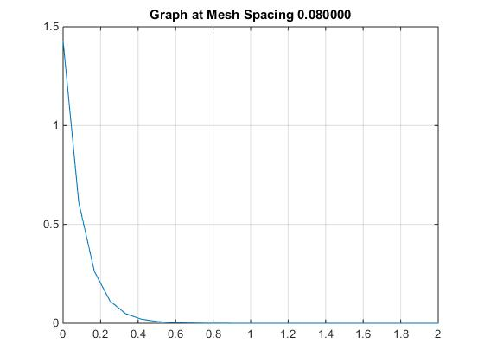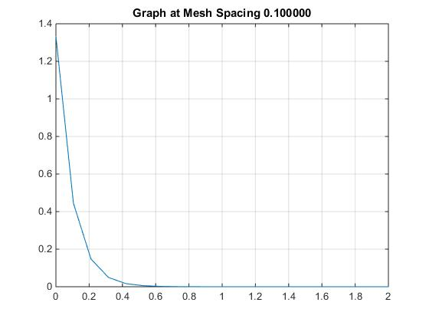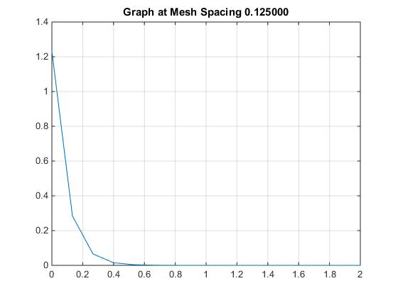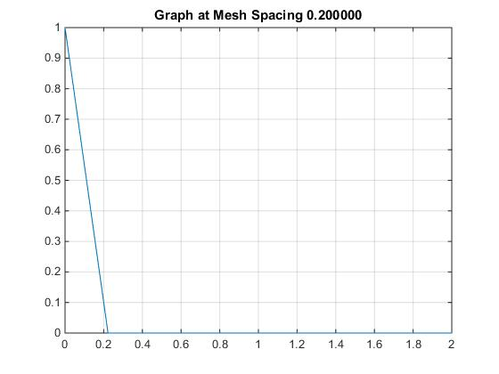

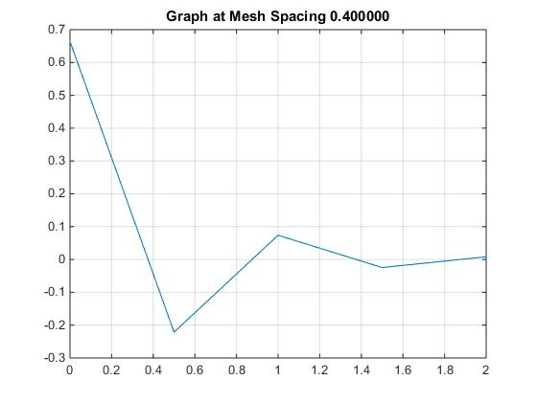

In this case, α = 0 for all graphs. When Δi = 0.4 we observe negative flux. This is the case as requirement stated in problem 2; mesh spacing (Δi) < 2µ/Σt doesn’t hold true (0.4 < 0.2).

1. Impact of α when α = [-0.9, -0.5, 0.25, 0.5, 0.9].

Let’s look at different α’s at Δi = 0.125. Graphs at other Δi are present in the folder.

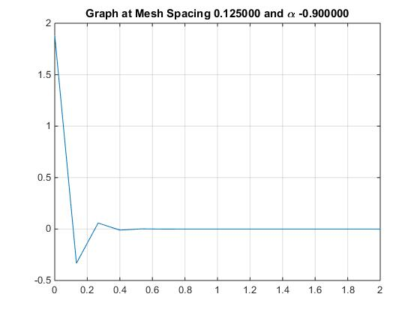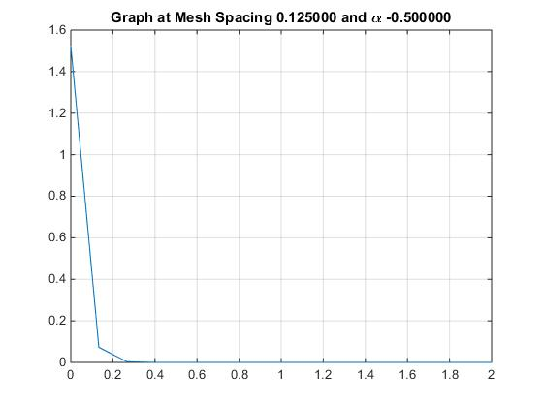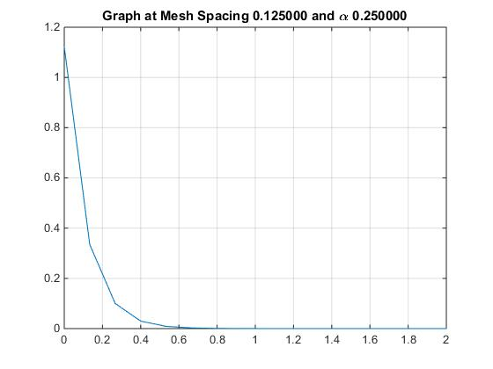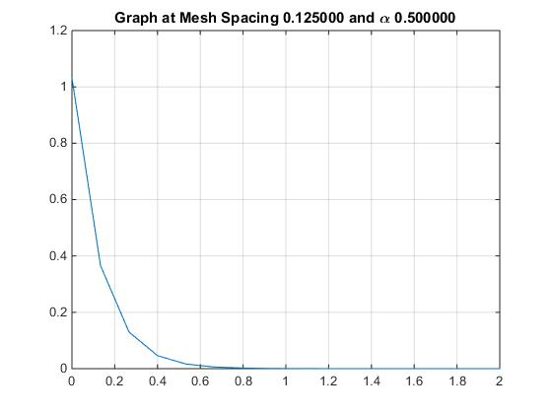 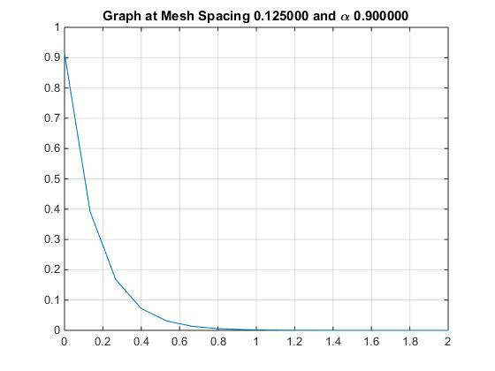

When α term is introduced, the requirement stated in problem 2 is changed by factor of 1+α in this case because of going x = 0 to x = 2. Δi*(1+α) < 2µ/Σt should hold true to prevent negative flux.

1. Adding source:

Graphs at µ = 0.7, α = 0.5, and for all mesh spaces here. Other graphs are in the folder.

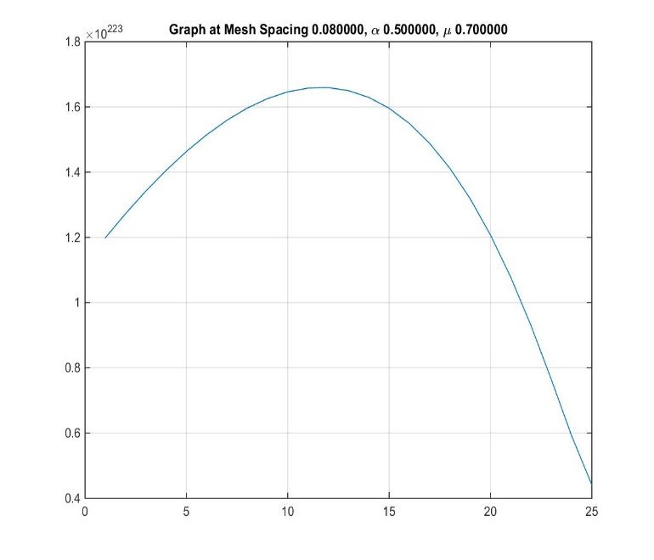 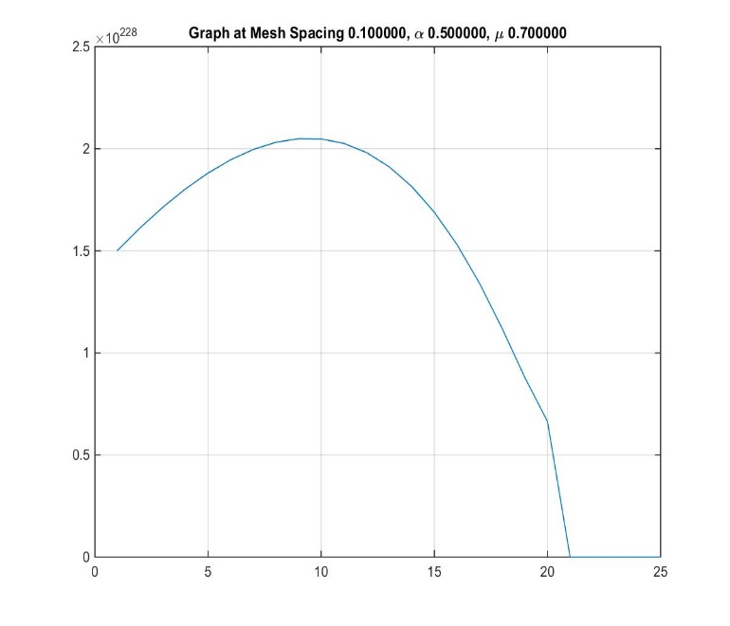 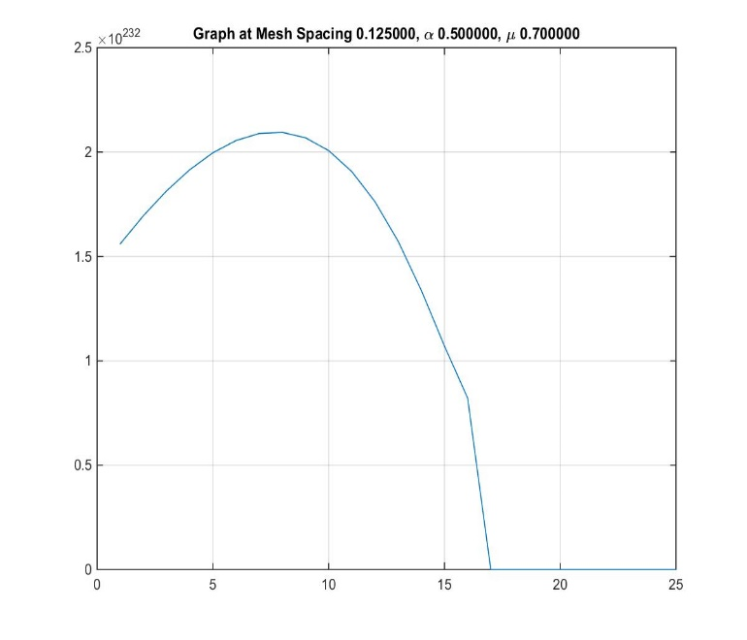 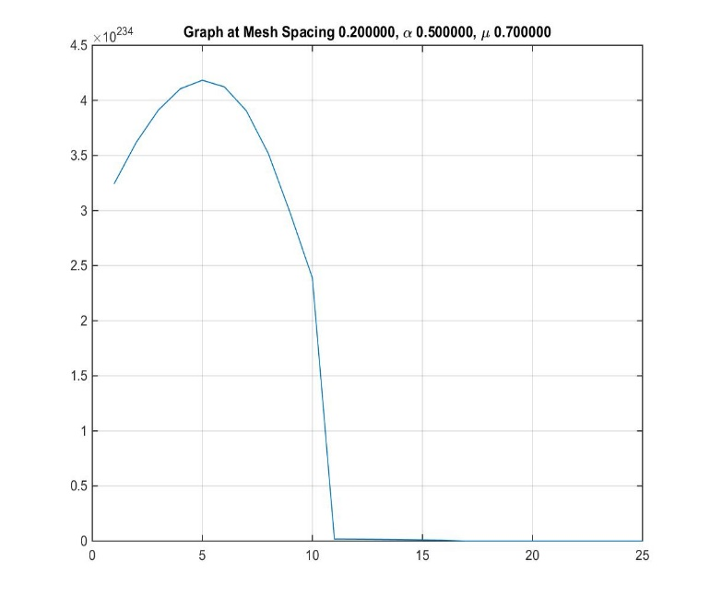 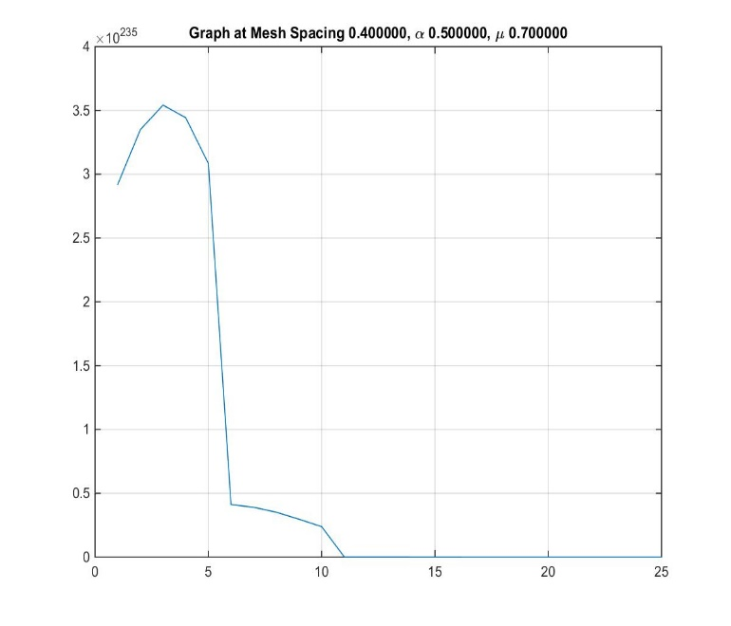

1. α = 0, Σs = 0.9:

As we increases Σs, the scalar flux increases.